- Cards
Cards using to show a single value on UI. Like when we need to show the figure of Total Sales, Total Registration, Total visitors etc than we will use Card visual. Here we can show the numbers in any format (Thousands, Lacs and Millions or in Percentage % etc) | 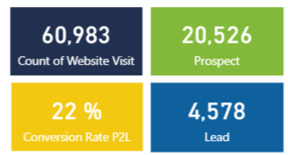
- Multi Row Card
Multi row card using for displaying the data in a Group format (or a section-wise). for example. if we need to display Total product, Total Sales, Margin % then we can use multi row card. | 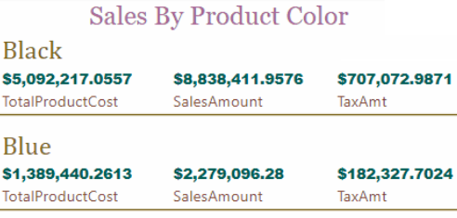
- Area Chart
Area charts are based on lines charts which use for showing the trends. Area chart mainly using for  - To display a trend for facilitates planning  - Trend for the different categories  - Showing the trend over time without having to show the exact values | 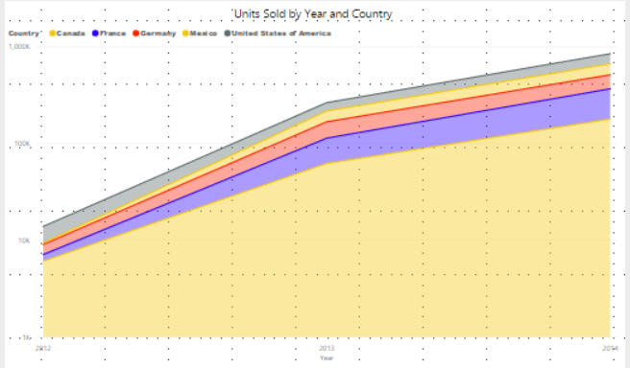
- Line Chart
When we need to show the exact value of the plotted data then we can use the line chart. Basically, line showing correlations between category and time values. For example, if we need to show total display monthly trends of products sold with data values then we will use line chart. Each point in the line is corresponds to a data value in the given category.  It’s also used for showing the trends on multiple legends (i.e. series of data), we can use 2 or more Y axes to showing the trends on same chart. | 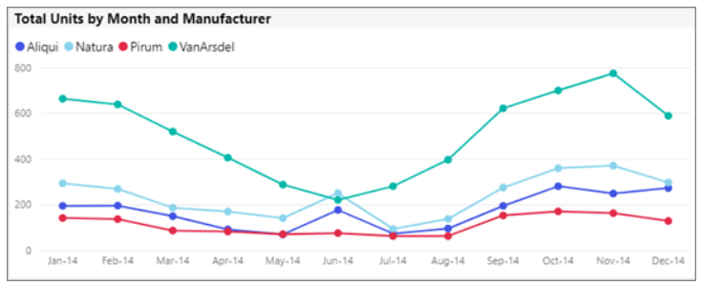
- Clustered Bar Chart
When need to horizontally data represents then we can use Bar Chart. This chart shows values (sum, count etc.) on X-axis and group by data on Y-axis. Mainly using for  - To compares data on category.  - When also need to represent negative values.  - When need to showing sales on the TOP N product / item / manufacture / city etc. | 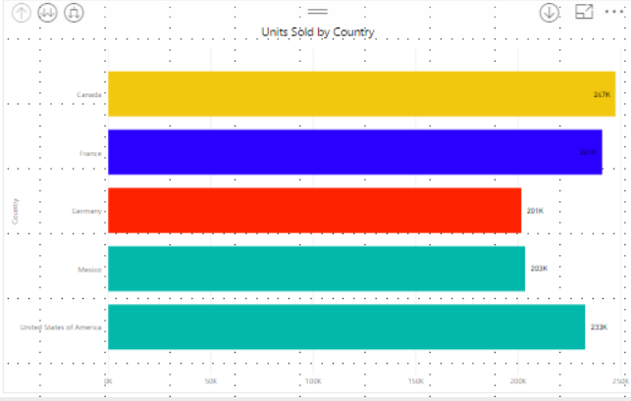
- Clustered Column Chart
Column chart are like Bar chart but column chart group the data from same category. This chart shows values (sum, count etc.) on Y-axis and group by data on X-axis. Here we can say multiple data Measures against a single Metric.  - Axis: Main Column that represents the Vertical Axis.  - Legend: Second Column that represents Vertical Bars (or bar colours).  - Values: Any Numeric value such as sales amount, Total Sales, etc. | 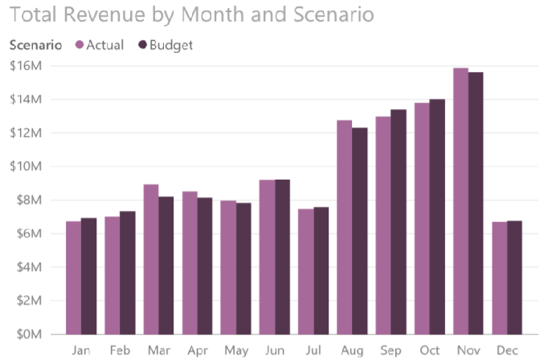
- Combo Chart
In Combo chart include both line and column chart. This chart mainly using –  - To compare multiple measures with different value ranges / Comparing data sets with different axis scales.  - Correlation between two measures in one visualization.  - Displaying trends as continuous data over time, set against a common scale | 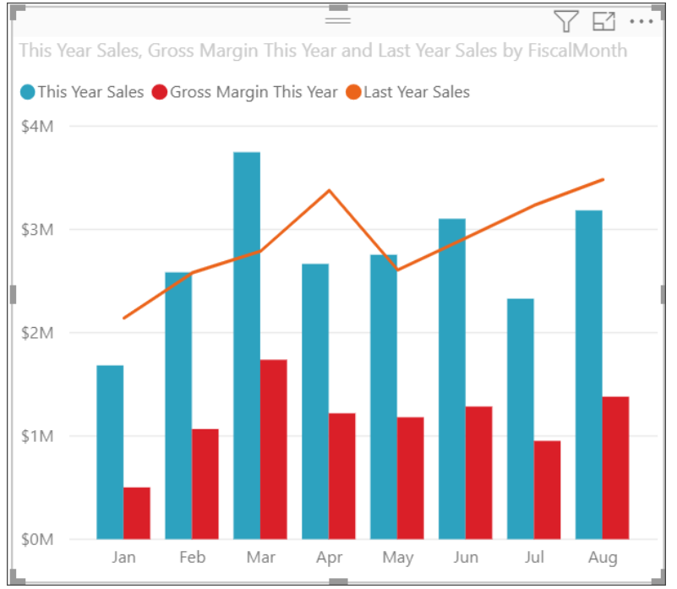
- Pie Charts
Pie charts using for showing the composition of the whole data in parts. Each component of a pie chart is represented in percentages and the sum of all the component equal 100%.  Pie chart is usually more effective than a bar graph when comparing a category with the total (the whole pie) in a single chart. Its most commonly used to make comparisons between groups with one data set.  It’s useful when want to see High-level data i.e. Sales by region. | 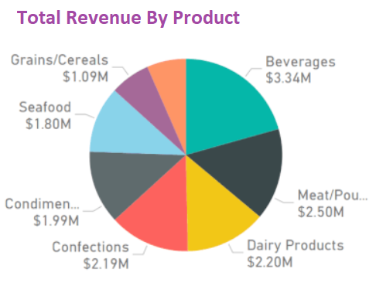
- Doughnut Charts
Doughnut chat like Pai chart, difference only is that the center is blank and allows space for a label or icon. Doughnut chart used to show the composition of the whole data in proportions. In doughnut charts, we can rotate the slices, focus on specific ones by pulling them out of the chart, or change the hole size to enlarge or reduce the size of the slices. | 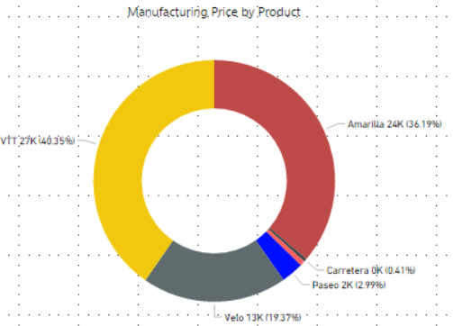
- Funnel Charts
Funnel chart results usually taper vertically from wide to narrow. It’s using when display variances in the stages of a process over time. We can say sequential connected stages. i.e. Sales Funnel Stages: Lead > Qualified Lead > Prospect > Contract > Close.  - When the data is sequential and moves through at least 4 stages.  - When the number of "items" in the first stage is expected to be greater than the number in the final stage.  - To calculate potential (revenue/sales/deals/etc.) by stages.  - To calculate and track conversion and retention rates.  - To reveal bottlenecks in a linear process.  - To track a shopping cart workflow. | 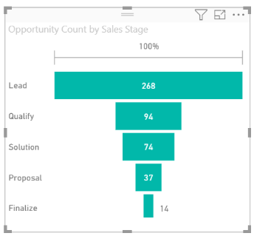
- Waterfall Chart
Waterfall chart useful to show the changes in a value over time. Used to show how an initial value has been affected by adding or subtracting subsequent values to the initial value to arrive at the final value. i.e.  - Track the revenue for the entire year to determine the net profit at the end of the year.  - When you have changes for the measure across time, a series, or different categories.  - To audit the major changes contributing to the total value.  - To plot your company's annual profit by showing various sources of revenue and arrive at the total profit (or loss).  - To illustrate the beginning and the ending headcount for your company in a year. | 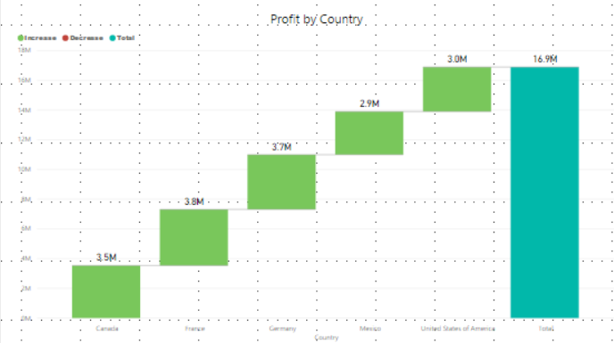
- Gauge Chart
Gauge charts are used to show the progress towards a goal /Target. Its showing what is the goal and how much achieved. Gauge charts are used to represent KPIs such as yearly sales goal of a company. The minimum and maximum values are predetermined and the line in the middle determines how far progressed towards your goal. | 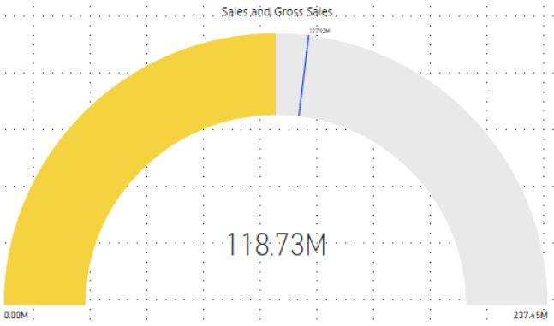
- Format Slicer
A slicer is a visual cue in Microsoft Power BI that viewers can use to interact with a data visualization. Slicer enables people to examine part of a data visualization more deeply through filtering. To keep the focus on the charts themselves, group all slicers together near the edge of the page. | 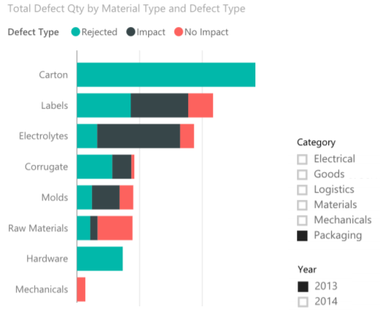
- KPIs -Key Performance Indicator
KPI use to showing, how effectively a company is achieving its key business objectives. Organizations use KPIs at multiple levels to evaluate their success at reaching targets. In other word - KPI is based on a specific measure and is designed to evaluate the current value and status of a metric against a defined target. | 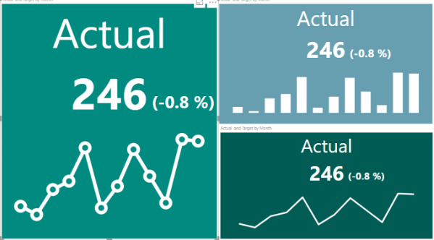
- Matrix
The matrix visual is like a table. Table supports two dimensions and the data is flat, meaning duplicate values are displayed and not aggregated. A matrix makes it easier to display data meaningfully across multiple dimensions -- it supports a stepped layout. The matrix automatically aggregates the data and enables drill down. We can view the sub total and total on each group. | 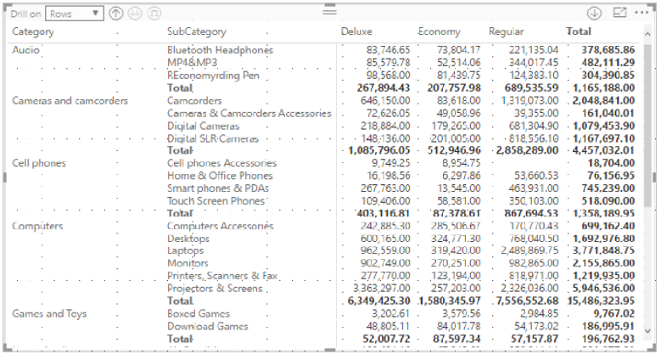
- 100% Stack Bar & Column Chart
100% Stacked Chart displays the metric information in percentages. | 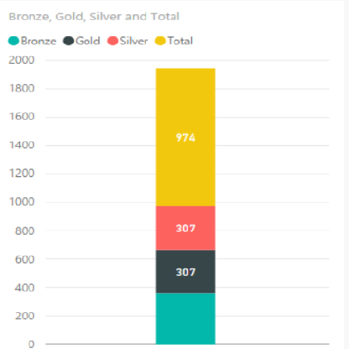
- Scatter & Bubble charts
A scatter chart shows the relationship between two numerical values. A bubble chart replaces data points with bubbles, with the bubble size.  Scatter charts –  - Show relationships between two numerical values.  - Plot two groups of numbers as one series of x and y coordinates  - To turn the horizontal axis into a logarithmic scale.  - To compare large numbers of data points without regard to time. | 